Chương I. THIS, MY, SOME, A LOT, ETC

Mục tiêu
Sau khi nghiên cứu xong chương này, học sinh có thể:
- Biết cách sử dụng các điểm ngữ pháp căn bản.
- Hiểu sử dụng các điểm ngữ pháp căn bản.
- Trình bày được các điểm ngữ pháp
- Áp dụng được các điểm ngữ pháp căn bản.
- Phân tích được các điểm ngữ pháp.

91 THIS, THAT, THESE, THOSE

1. INTRODUCTION

Demonstrative Pronoun: THIS, THAT, THESE, THOSE

1.1 This/These: is used for things near the speaker (this printout here).

This goes with a Singular or Uncountable Noun.
THIS + Singular/Uncount. N + V (Singular)
THESE + Plural N + V (Plural)

E.g1: Look at this table! It is very new. This furniture is very expensive.

Singular N Uncount. N

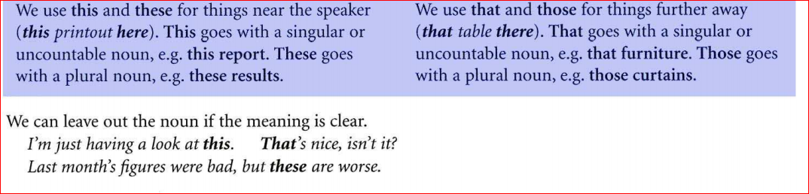

1.2. That/Those: to replace nouns that are farther away in space and time.
If the noun you are referring to is far from you, either physically or figuratively,
you can replace it with those.
Eg: That man over there is holding three chocolate bars. Do you want all of those? (Those replaces chocolate bars.)
E.g: These hats are very nice.

Plural N
THAT + Singular/Uncount. N + V (Singular)
THOSE + Plural N + V (Plural)

2. PLACES and PEOPLE
2.1 When we are in a place or a situation, we use this (not that) to refer to it.
Eg: There’s a wonderful view from this office. Just come to the window.
This party isn’t much fun, is it? Shall we go home?
2.2 We can use this to introduce people and that to identify people.
Eg: Jake, this is my friend Rita. That’s Andrew over there.
On the phone we can use this to say who we are and this or that to ask who
the other person is.
Eg: Hello ? This is Laura speaking. Who’s this/that, please ?

3. TIME
THIS/THESE can mean “near in time”
THESE/THOSE “further away in time”
Eg: I’m working as a tourist guide this summer. I’m pretty busy these days.
Do you remember that summer we all went to Spain ? Those were the days.
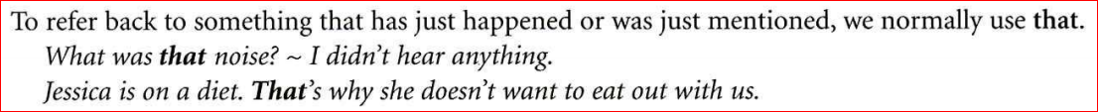
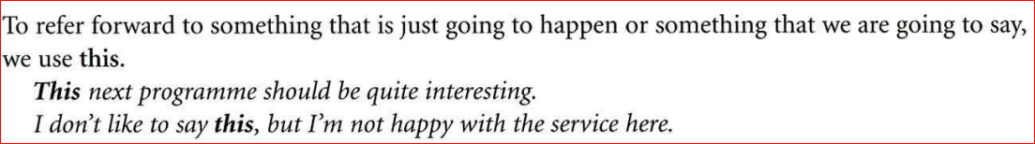

92 MY, YOUR, etc, and MINE, YOURS, etc
- INTRODUCTION: Possessive Adjective
Personal Pronoun | Possessive Adjective | Meaning
I | My | Của tôi
You | Your | Của bạn, anh chị…
He | His | Của anh ấy
She | Her | Của cô ấy, chị ấy
It | Its | Của nó
You | Your | Của bạn, anh chị…
We | Our | Của chúng tôi, chúng ta
They | Their | Của họ

Eg1: I am a student. My school is in Tan Binh district.

Personal Pronoun Possessive Adjective
Eg 2: I have a brother. His brother is a doctor.

Personal Pronoun Possessive Adjective
- ITS and IT’S
*ITS: before a Noun to express the idea of belonging.
ITS + N

Eg: The street is around here somewhere, but I’ve forgotten its name.

*ITS = IT IS/ IT HAS
Eg: I think it’s time to go. ( = it is)
It’s got a lot colder today.

- MY, YOUR with parts of the body and clothes

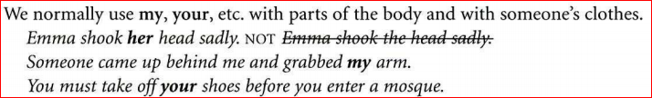

But We usually use MY, YOUR, etc. with parts of the body and with someone’s clothes.

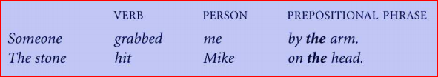

- OWN: after MY, YOUR, etc. to say that something belongs to us and to
no one else.

- A FRIEND OF MINE

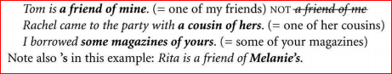

*Note: Rita is a friend of Melanie’s.

93 THE POSSESSIVE FORM and OF
- FORM
We use the possessive of a Noun in phrases like the boy’s name and Vicky’s room.
Singular N + ‘S
Eg: boy bo y’s, VickyVicky’s
Plural N + ’
Plural noun ending in s: |  |  | ‘boys hois’ | tourists tourists’
Plunal noun not ending in s: |  | ’s | men men’s | child children children’s
We can use the possessive form with another noun or on its own.
I’ve met Rachel’s family, but I haven’t met Vicky’s. (Vicky’s —— Vicky's family)

- The boy’s name or the name of the boy?
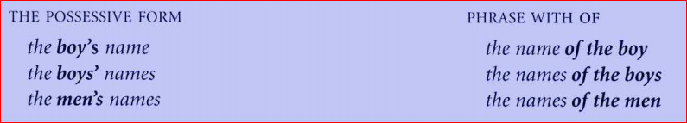

Sometimes we can use either the possessive (the boy’s name) or a phrase with of (the name of the boy), but often only one is possible.

We normally use the possessive with people and animals.
Claire’s idea Daniel’s brother our neighbour’s garden the dog’s owner
the policemen’s uniforms the women’s changing room the Parkers’ car

We normally use of with things, and not the possessive form
Eg: the side of the house, NOT the side of the house

But we use of with people when there is a long phrase.
Eg: the address of those people we met in Spain, NOT those people who we met in Spain’s address.

We can use both structures for places and organizations.
London’s museums or the museums of London

- The possessive of time

We can use the possessive to say 'when’ or 'how long
last week’s concert today’s TV programmes
yesterday’s news about a month’s work ten minutes’ walk
*Note: in two months’ time (two months from now)
a week’s wages (wages for a week)

94. SOME AND ANY

1. Basic use

Some and any go before a plural or uncountable noun
SOME + UNCOUNT. NOUN
ANY PLURAL NOUN

There was a bowl and some cornflakes on the table, but there wasn’t and milk.

We can also use some and any without a noun.
Trevor wanted some milk, but he couldn’t find any.

We normally use some in positive sentences and any in negative sentences or ones with a negative meaning.

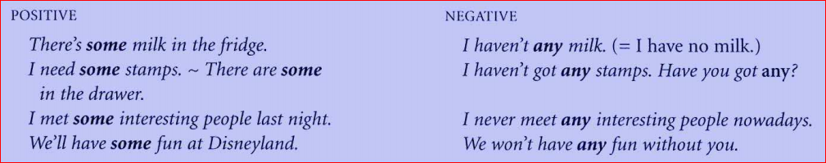

We can also use any in a sentence with if.
Eg: If you have any problems, you can discuss them with your group leaders.
I can answer any questions. = If there are any questions, ...

In questions we can use either some or any, but any is more common.

Eg: We don’t know whether the answer will be yes or no.
Have we got and butter? Will there be and food for the guests?

We normally use some in offers and requests to make them sound more positive.
Eg: Would you like some coffee? Could you post some letters for me?

We can use some in questions when we think the answer might be yes.
Did you buy some clothes? (Perhaps I know that you went out to buy some.)

Someone, anything, etc.

We choose between someone and anyone, something and anything, and somewhere and anywhere in the same way as between some and any.

Another use of any

We can use any in a positive sentence to mean ‘it doesn't matter which!
I’m free all day. Call any time you like.
Any student will be able to tell you where the college library is. You can buy these maps at any petrol station. They all have them.

We say any petrol station because all petrol stations have the maps. It doesn’t matter which onc you go to. They are all equally good.
Look at these examples with anyone, anything and anywhere.
It’s a very simple puzzle. Anyone could solve it. (= It doesn’t matter who.)
What shall we have for lunch? - Oh, anything. I don’t mind.
Where do we have to sit? - We can sit anywhere. It doesn’t matter.

95 A lot of, lots of, many, much, (a) few and (a) little

Introduction

A lot of, lots of, many and much mean a large quantity.
A few and a little mean a small quantity.
Many + Plural nouns
A few

Eg: many problems, a few buildings

Much + Uncountable Nouns

A little
Eg: much trouble, a little sunshine

A lot of + Plural Nouns
Lots of Uncountable nouns

Eg: a lot of tourists lots of games
a lot of sugar lots of fun

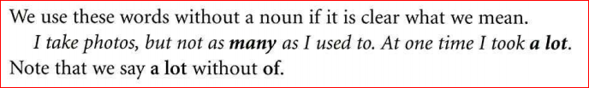

2. A lot of, many and much

a lot of and lots of : positive statements
many and much: negatives and questions.
Positive: | We get a lot of storms here. | We get a lot of rain here.
Negative | We don’t get many storms | We don’t get much rain here.
Questions:  Too + many  So much (not a lot of )  As | Do you get many storms here? | Do you get much rain here?
There are too many cars.
I’ve got so much work.
I haven’t got as much money as you.

In formal English, we can sometimes use many and much in a positive statement.
Eg: Many students have financial problems. There is much enthusiasm for the idea.
But this is less usual in conversation, where we normally use a lot of or lots of.

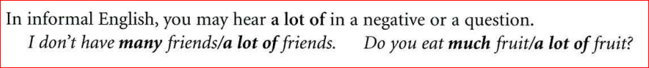

3. Few and little with and without a

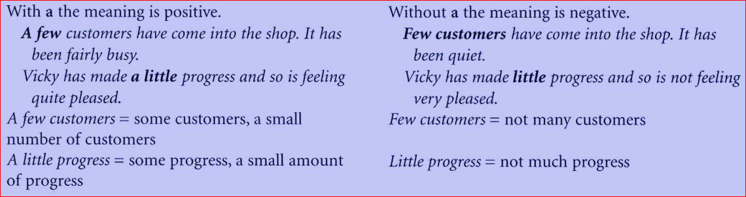

Few and little (without a) can be rather formal.
In informal speech we can use these structures.
Not many customers have come in. Vick y hasn’t made much progress.
Only a few customers have come in. Vicky has made only a little progress.

96. All, half, most, some, no and none
- All, most and some

All Plural Noun
Most +
Some Uncountable Noun

Eg: All plants need water.

All matter is made up of atoms.
Most people would like more money. Some food makes me ill.
All plants means ‘all plants in general/ in the world.
Most people means ‘most people in this country/in the world.
Some food means 'some food but not all food' Here some is pronounced /swm/.

2. All of, half of, most of and some of
All of + Demonstrative Pronouns

Eg: Why do you keep all of these clothes?

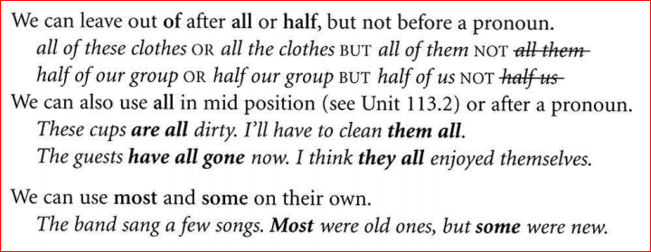

3. All meaning ‘everything’ or ‘the only thing’

We can use all with a clause to mean 'everything’ or 'the only thing'
Eg: Tell me all you know. All I did was ask a simple question.

Clause Clause

Note: Tell me everything. NOT Tell me all.

- No and none
NO + Count. Noun
Uncount. Noun

Eg: We’ve rung all the hotels, and there are no rooms available.
I’m afraid I’ve got no money. (= I haven’t got any money.)

We use none with of or on its own.
Eg: None of my friends will be at the part y. Look at these clothes.
None of them are in fashion now.
I wanted some cakc, but thcre was none left. NOT

97. EVERY, EACH, WHOLE, BOTH, EITHER AND NEITHER

1. Every and each

We use every and each before a singular noun to talk about a whole group.
The police questioned every person/each person in the building.
Every room/Each room has a number.
In many contexts either word is possible, but there is a difference in meaning.

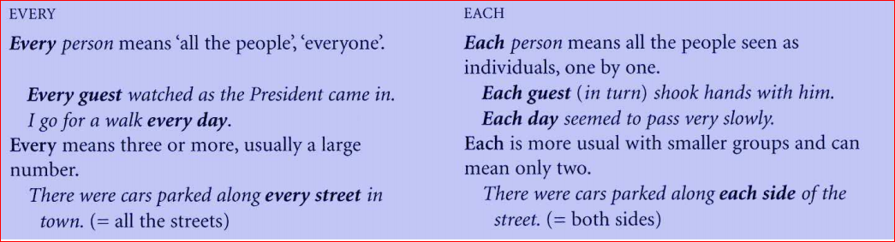

We can use each (but not every) on its own or with of.
There are six flats. Each has its OWN entrance. NOT Every has
Each of the six flats has its own entrance. NOT Every of the …
We can also say Each one/Everyone has its own entrance.

We can also use each in mid position or after a pronoun.

We’ve each got our o wn desk. They gave us each a desk.

Compare every and all before day, morning, week, etc.
I travel every day. (= Monday, Tuesday, Wednesday, ...)
I was travelling all day. (= from morning till evening)

2. WHOLE

We use whole before a singular noun. It means all’ or 'complete'
The baby cried the whole time. (= all the time)
I’ve spent my whole life waiting for this moment. (= all my life)
We’ll need a whole loaf to make sandwiches)or everyone.

3. Both, either and neither

We use both, either and neither for two things.
Eg: I’ve got two bicycles. Both of them are quite old. I’ve given up cycling, so
I don’t ride either of them and more. Neither of them is in very good condition, I’m afraid.

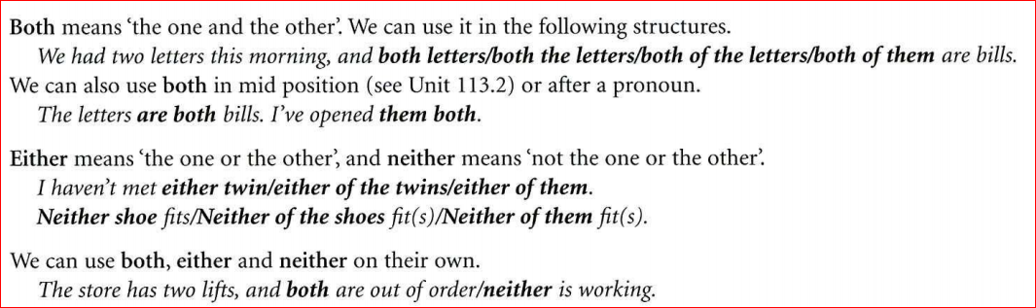

Chương II. PRONOUN

Mục tiêu
Sau khi nghiên cứu xong chương này, học sinh có thể:
- Biết cách sử dụng các điểm ngữ pháp căn bản.
- Hiểu sử dụng các điểm ngữ pháp căn bản.
- Trình bày được các điểm ngữ pháp
- Áp dụng được các điểm ngữ pháp căn bản.
- Phân tích được các điểm ngữ pháp.

- PERSONAL PRONOUNS (I, YOU)

The meaning of the pronouns

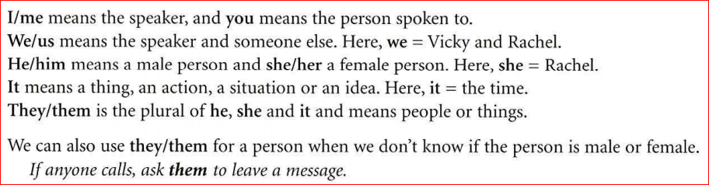

2.Subject and object forms

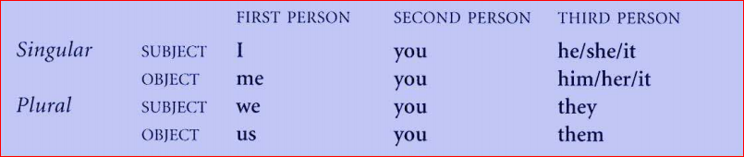

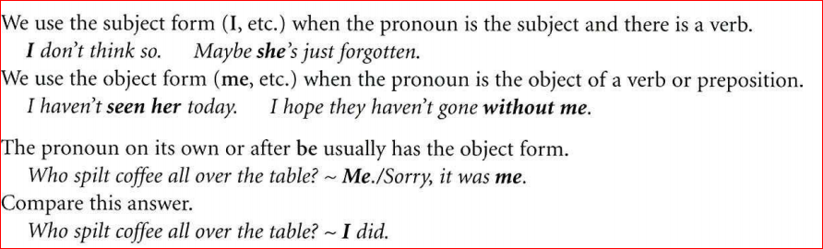

3.You, one and they

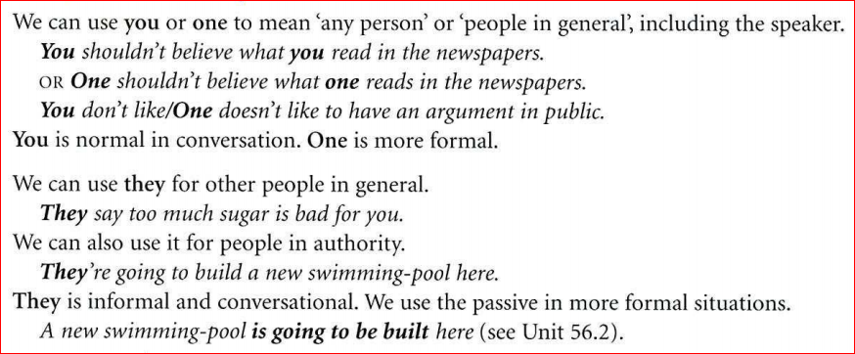

- There and it

There + be: To talk about the existence of something. Be agrees with the following noun.
Eg: There is a phone box. BUT There are some eggs.

We also use there with words like a lot of, many, much, more, enough and with numbers.
There were a lot of problems to discuss. There’s too much noise in here.
Will there be enough chairs? There are thirty days in April.

2.Uses of it

We use it for a thing, an action, a situation or an idea.
You’ve bought a new coat. It’s very nice. (it = the coat)

We use it to mean 'the unknown person'
Did someone ring? - It was itchy. She just called to say she’s arrived safely.

We use it for the time, the weather and distance.
It’s half past five already. It’s Sunday tomorrow.

We also use it in structures with a to-infinitive or a that-clause (see also Unit 67.2).
It was nice to meet your friends.
It’s a pity (that) you can’t come with us.
This is much more usual than, for example, To meet your friends was nice.
3. There or it?

We often use there when we mention something for the first time.
There was a picture on the wall. It was an abstract painting.

We use it when we talk about the details. It means the picture.
There’s a woman at the door. - Oh, it’s Aunt Joan.

- Reflexive pronouns
1.Introduction

Myself is a reflexive pronoun. In the sentence
I’ve cut myself, the words I and myself mean
the same thing. Myself refers back to the subject, I.
- Form
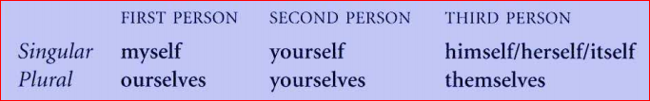
Compare yourself and yourselves.
Emma, you can dry yourself on this towel. Vicky and Rachel, you can dry yourselves on these towels.

The use of reflexive pronouns
We cannot use me, you, him, etc. to refer to the subject. Compare these sentences.
When the policeman came in, the gunman shot him. (him = the policeman)
When the policeman came in, the gunman shot himself. (himself = the gunman)
Reflexive Pronoun + Preposition

The children are old enough to look after themselves.
But after a preposition of place, we can use me, you, him, etc.
In the mirror I saw a lorry behind me. Mike didn’t have any money with him.

Idioms with reflexive pronouns
We really enjoyed ourselves. (= had a good time)
I hope the children behave themselves. (= behave well)
Just help yourself to sandwiches, won’t you? (= take as many as you want)

5.Verbs without a reflexive pronoun
Some verbs do not usually take a reflexive pronoun, although they may in other languages.
We’d better hurry, or we’ll he late. NOT We’d better hurry ourselves.
Some of these verbs are: afford, approach, complain, concentrate, decide, feel + adjective, get up, hurry (up), lie down, meet, remember, rest, relax, sit down, stand rip, wake up, wonder, worry
We do not normally use a reflexive pronoun with change ( clothes), dress and wash.
Daniel washed and changed before going out. (See also Unit 54.4.) But we can use a teñexise pronoun when the action is difficult.
My friend is disabled, but she can dress herself.

- Emphatic pronouns and each other
Trevor and Laura are decorating their living-room themselves.

An emphatic pronoun is a word like myself, yourself.
It has the same form as a reflexive pronoun.
Here the emphatic pronoun means ‘without help' Trevor and Laura are decorating the room without help from anyone else.
Laura are decorating the room without help from anyone else.
I built this boat myself. M y sister designs all these clothes herself. Are you doing all the painting yourselves?
When we say these sentences, we stress self or selves.
- Each other
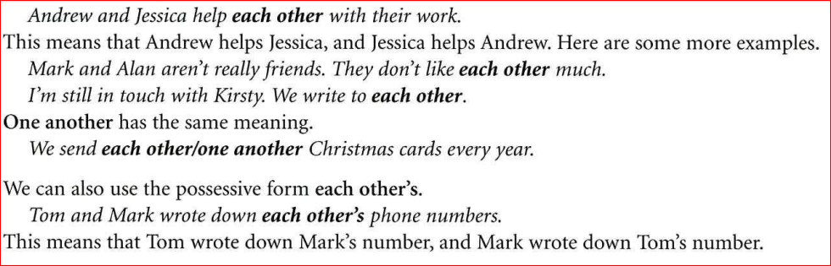

102 The pronoun one/ones

1.Introduction
We use one for a singular noun and ones for a plural noun.
We use one and ones to avoid repeating a noun.
We cannot use one or ones with an uncountable noun, e.g. water.
There was no hot w ter. I had to wash in cold.

Structures with one/ones
Sometimes we can either put in one/ones or leave it out.
These bowls are nire. What about this (one )?
We can do this after this, that, these and those; after each or another; after which; or after a superlative, e.g. easiest.
I don’t like these sweaters. I prefer those (ones ) over there. I tried all three numbers, and each (one) was engaged.
The product is available in all these colours. Which (one ) would you like?
The last question is the most difficult (one).
Sometimes we cannot leave out one/ones.
Our house is the one on the left. NOT Our house is the one on the left. .
We cannot leave out one/ones after the or every or after an adjective.
The film wasn’t as good as the one we saw last week.
I rang all the numbers, and every one was engaged.
I’d like a box of tissues. A small one, please.
I threw away my old trainers and bought some new ones.

A small one and one
We can say a small one, a red one, etc. but NOT a one
I’ve been looking for a coat, but I cat1’t find a nice one.
I’ve been looking for a coat, but I can’t find one.
Here we use one instead of a coat. Here are svme more examples.
One and some/any are like a, but it and they/them are like the. We use one and some/any when we aren’t saying which, and we use it and they/them to be specific (when we know which).
I haven’t got a passport, but I’ll need one. (one = a passport)
I haven’t got any stamps, but I’ll need some. (some = some stamps)
I’ve got nay passport. They sent it last week. (it = the passport)
I’ve got the stamps. I put them in the drawer. (them = the stamps)

- Everyone, something, etc.

1. Introduction

With every, some and no, we can form words ending in one, body, thing and where.

Words ending in thing can also mean actions or ideas.

Something awful has happened. You must tell me everything.
- Someone and anyone, etc.
We can also form words with any: anyone, anybody, anything, anywhere.
We can also use words with any in a positive sentence.
This door is always left open. Anyone could just walk in here.
Where shall we go? - Anywhere. I don’t mind.
Anyone means ‘it doesn’t matter who’, and anywhere means 'it doesn’t matter where!
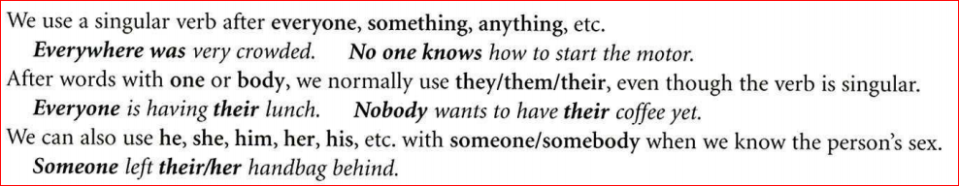

4. Other structures
After everyone, something, etc. we can use an adjective.
Let’s go somewhere nice. Is there anything interesting in that magazine?
We can also use else.
We always play Scrabble. Lct’s play something else. (= a different game)
Henry wore a suit, but everyone else had jeans on. (= all the other people)
Words ending in one and body have a possessive form (with ’s).
Someone’s cat is on our roof. I need to be informed about everybody’s plans.

Chương III. ADJECTIVES AND ADVERDS

Mục tiêu
Sau khi nghiên cứu xong chương này, học sinh có thể:
- Biết cách sử dụng các điểm ngữ pháp căn bản.
- Hiểu sử dụng các điểm ngữ pháp căn bản.
- Trình bày được các điểm ngữ pháp
- Áp dụng được các điểm ngữ pháp căn bản.
- Phân tích được các điểm ngữ pháp.

104 Adjectives


Introduction
,.
‘•
*
Henry and Claire are having dinner in a quiet restaurant. It’s a warm evening. The food is delicious. Henry is feeling romantic.
An adjective is a word like quiet, warm, delicious, romantic. The word quiet describes the restaurant. It tells us what the restaurant is like.

Word order
There are two places where we can use an adjective:
before a noun (a quiet restaurant) and after a linking verb feeling romantic).
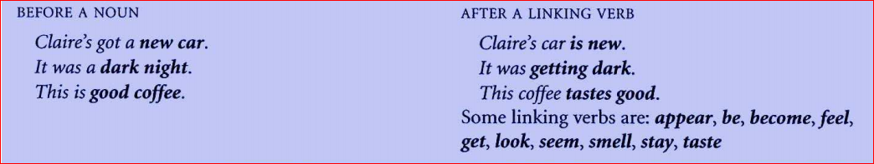
We can use two or more adjectives together (see Unit 105).
It’s a quiet little restaurant. Mike was wearing a dirty old coat.
We can put a word like very or quite before an adjective.
It was a very dark night. Henry was feeling quite romantic.
Very and quite are adverbs of degree (see Unit 115).
3.Adjectives used in one position only
We can use most adjectives in both positions — before a noun or after a linking verb. But a few adjectives can go in one position but not in the other.
Some more examples are: chief (= main), elder (= older), eldest (=oldest), inner, outdoor, outer, principal (=main), upper
At last the baby is asleep. Emma’s two brothers are very alike.
I’m really pleased to see you. Vicky looked ill, I thought.
Some more examples are: afraid, alone, ashamed, awake, alive, content (= happy), fine (= in good health), glad, unwell, well

105 Adjectives (order)
- Introduction

It’s beautiful sunny weather. Nick has got a big black dog.
We can use more than one adjective before a noun. There is usually one correct order.
We cannot say sunny beautiful weather or a black big dog

2.Adjectives and nouns

We sometimes use two nouns together (see Unit 82).
a glass door a computer program
Here we use glass like an adjective, to describe the door. When we use another adjective as well (e.g. heavy), it comes before both the nouns.
a heavy glass door a useful computer program

3.Word order
We order adjectives according to their meaning. This is the normal order:
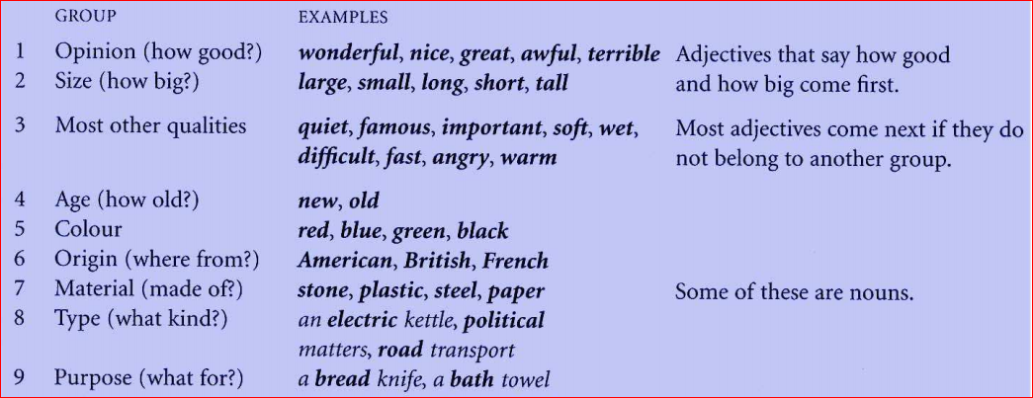
a small green insect (size, colour) Japanese industrial designers (origin, type)
a wonderful new face cream (opinion, age, purpose) awful plastic souvenirs (opinion, material)
a long boring train journey (size, quality, type) some nice easy quiz questions (opinion, quality, purpose)
a beautiful wooden picture frame (opinion, material, purpose)

We sometimes put commas between adjectives in Groups 1—3
a horrible, ugly building a busy, lively, exciting city

106 The old, the rich, etc.
1 Introduction

There are some adjectives that we can use with the to talk about groups of people in society,
e.g. the disabled, the blind. Here are some more examples.
What can we do to feed the hungry? The rich can afford to yaw more taxes.
The young are usually keen to travel. It is our duty to care for the sick.

What adjectives can we use?
These are some of the adjectives and other words that we can use in a phrase with the.
To do with social or economic position:
the disadvantaged, the homeless, the hungry, the poor, the privileged, the rich, the starving, the strong, the underprivileged, the unemployed, the weak
To do with physical condition or health:
the blind, the deaf, the dead, the disabled, the handicapped, the living, the sick
To do with age:
the elderly, the middle-aged, the old, the over-sixties, the under-fives, the young

We can sometimes use an adverb before the adjective.
The very poor are lefi without hope. The severely disabled need full-time care.
There are some adjectives in this structure that normally have an adverb.
The less fortunate cannot afford to go on holiday.
Should the mentally ill be allowed to live in the community?
3.The young or the young people?
The young means 'young people in general'
The young have their lives in front of them.
When we mean a specific person or a specific group of people, then we use man, woman, people, etc.
There was a young man standing on the corner.
I know the young woman in reception the lives in our street.
None of the young people in the village can find jobs here.

107 Interesting and interested

Introduction
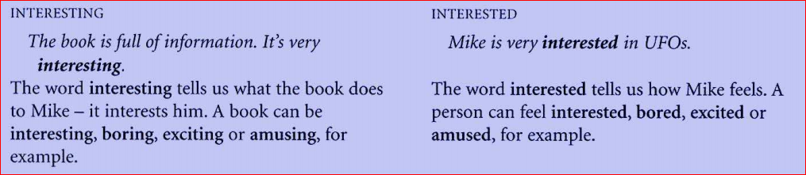

Adjective pairs
Here are some more examples.

- ING - ED
Tom told us an amusing story. We were amused at Tom’s story.
The two-hour delay was annoying. The passengers were annoyed about the delay.

I didn’t enjoy the party. It was boring. I went to the party, but I felt bored.
This computer has some very confusing I got ver y confused trying to make instructions. sense of the instructions.

108 Adjective or adverb? (1)

Introduction
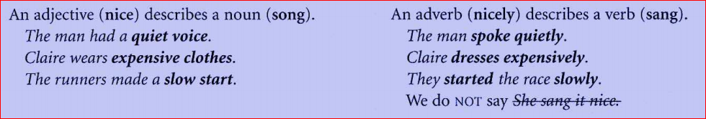
We can use adverbs in other ways. An adverb like really or very can be combined with an adjective (hot) or another adverb (carefully) (see Unit 115).
It was really hot in the sun. Andre w checked his work very carefully.
An adverb like fortunately or perhaps says something about the whole situation.
Fortunately nothing was stolen. Perhaps Sarah is working late.
- The -ly ending
We form many adverbs front an adjective + -ly. For example politely, quickly, safely. But there are some special spelling rules.
1.We do not leave out e, e.g. nice nicely Exceptions are true —• truly, whole —• wholly.
2. -y -ily after a consonant, e.g. easyeasily, luckyluckily, angrily, happily, heavily, etc.
3. -ie -ly, e.g. possible possibly
Also comfortably, probably, reasonably, sensibly, terribly, etc.
4. -ie -ically, e.g. dramatic dramatically
Also automatically, scientifically, etc. (Exception: publicly)

Looked nice and looked carefully
Compare these two structures.

LINKING VERB + ADJECTIVE ACTION VERB + ADVERB
Tom was hungry. Paul ate hungrily.
The children seemed happy. The children played happily.
My soup has got cold. The man stared coldly at us.
An adjective can come after a linking verb such as We use an adverb when the verb means that be (see Unit 104.2). something happens.

Some verbs like look, taste and appear can be either linking verbs or action verbs.
LINKING VERB -I- ADJECTIVS
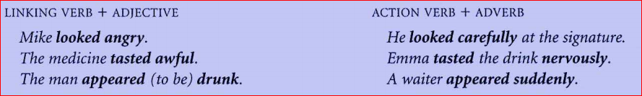

109Adjective or adverb? (2)

- Friendly, likely, etc.

The ending -ly is the normal adverb ending (see Unit 108). But a few adjectives also end in -ly.

Melanie was very friendly. It vas a lively part/.We had a lovely time.
Some more examples are: elderly, likely, lonely, silly, ugly
The words are adjectives, not adverbs (NOT She spoke to us friendly). We cannot add-ly. There is no such word as friendily. But we can say in a friendly way/manner.
She spoke to us in a friendly way.
If we need to use an adverb, we often choose another word of similar meaning.
It was lovely. Everything went beautifully.

- HARD, FAST, etc
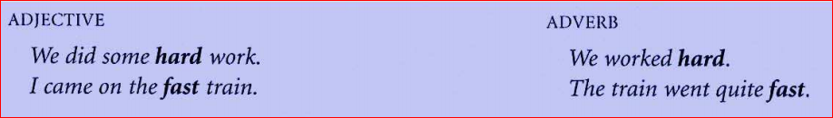

We can use these words both as adjectives and as adverbs: deep, early, fast, hard, high, late, long, low, near, right, straight, wrong (For hardly, nearly, etc, see 3.)
In informal English, the adjectives cheap, loud, quick and slow can be adverbs.
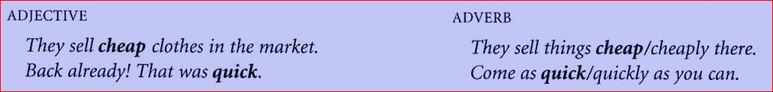
- Hard, hardly, near, nearly, etc
There are some pairs of adverbs like hard and hardly which have different meanings.
I tried hard, but I didn’t succeed.
I’ve got hardly any money left. ( hardly any = very little, almost none)
Luckil y I found a phone box quite near. I nearly fell asleep in the meeting. ( nearl y =almost)
Rachef arrived late, as usual. I’ve been ver y bus y lately. (lately = in the last few days/weeks)
- GOOD and WELL
Good is an adjective, and well is its adverb. The opposites are bad and badly.
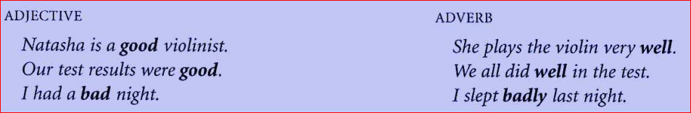
Well can also be an adjective meaning ‘in good health’, the opposite of ill.

My mother was ver y ill, but she’s quite well again now'.

How are you? - Very well, thank you.

110. Comparative and superlative forms

1. The comparison of adjectives

We form the comparative and superlative of short adjectives (e.g. cheap) and long adjectives (e.g. expensive) in different ways.

 | COMPARAT1VE | SUPERLATIVE
Short word, e.g. cheap: | cheaper | (the ) cheapest
Long word, e.g. expensive | more expensive | (the ) most expensive
For less and least, see Unit 112.1.
There are sonic less expensive ones here, look.

2.Short and long adjectives
One-syllable adjectives (e.g. small, nice) usually have the -er, -est ending.
Your hi-fi is smaller. Emma needs a bigger computer.
This is the nicest colour. This room is the warmest.

But we use more, most before words ending in -ed.
Everyone was pleased at the results, but Vicky was the most pleased.
We also use more, most with three-syllable adjectives (e.g. ex-cit-ing) and with longer ones.
The film was more exciting than the book. This Press is more elegant.
We did the most interesting project. This machine is the most reliable.

Some two-syllable adjectives have -er, -est, and some have more, most. Look at this information.
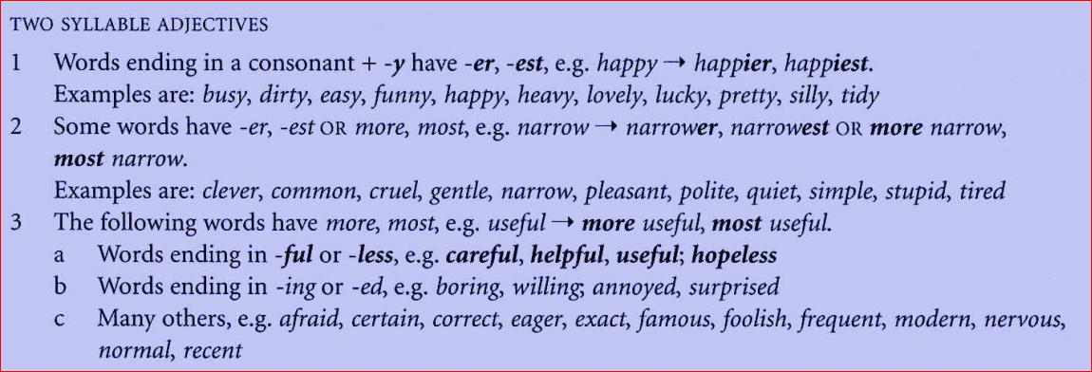

3.SPELLING
There are some special spelling rules for the –er and –est endings.
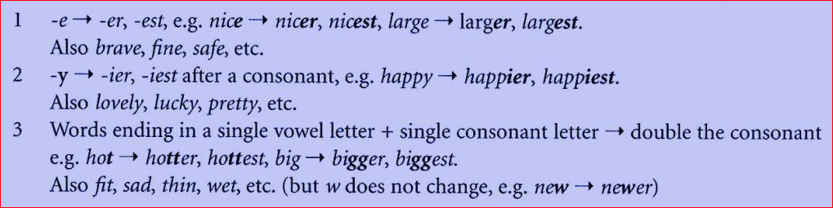
4.The comparison of adverbs
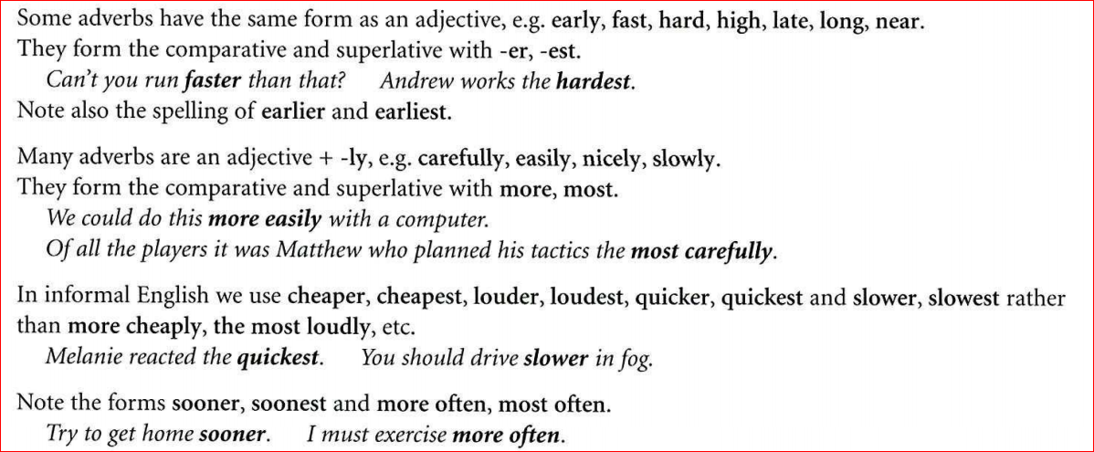
- IRREGULAR FORMS
Good, well, bad, badly and far have irregular forms.
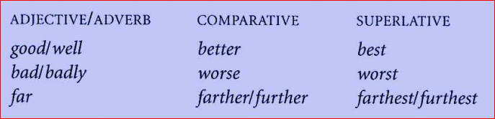
You’ve got the best handwriting. How much further are we going?
We can use elder, eldest + Noun instead of older, oldest, but only for people in the same family.
My elder/older sister got married last year.
- COMPARING QUANTITIES
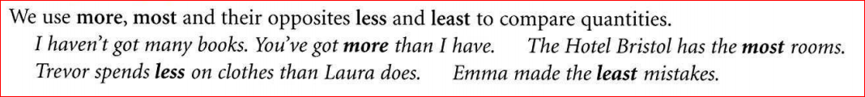
111

